Individual Weekly Report for Sam Baranov

Building a Unified Fitness Tracker System for Automated Progression Tracking and Planning

August 18, 2025

# Accomplishments

* Implemented exercise set tracking with custom metrics
* Implemented UI for individual exercises during a workout
* Reworked exercise database UI
* Reworked exercise creation UI
* Reworked workout exercise UI
* Implemented a theme system for easier UI styling
* Created portfolio drafted
* Held stakeholder meeting
* Held a code review
* Completed career activities

# Weekly Activities

| Activity / Task / Work | Hours | Status |
| --- | --- | --- |
| Set tracking with custom metrics | 2 | Complete |
| Current exercise workout UI | 4.5 | In progress |
| Exercise database UI changes | 3.5 | Complete |
| Exercise creation UI rework | 2 | In progress |
| Workout exercise list UI | 1 | In progress |
| Theme system implementation | 4 | Complete |
| Portfolio draft | 1.5 | Complete |
| Portfolio meeting | 1 | Complete |
| Stakeholder meeting | 1.5 | Complete |
| Code review | 1.5 | Complete |
| Handshake profile revamp | 1 | Complete |
| Interview Questions | 1 | Complete |
| **Weekly Total** | **24.5** |  |
| Previous Weekly Cumulative Total (Carry Over) | 139 |
| **Current Cumulative Total** | **163.5** |

# Plans for Next Week

| Activity / Task / Work | Est Hours |
| --- | --- |
| Finish prototype UI clean-up | 3-5 |
| QA and user testing | 2-3 |
| Portfolio work | 2-3 |
| Code cleanup and refactoring | 5-10 |

# Response to Feedback

This has been the most productive week in terms of feedback. I received a code review and a different stakeholder meeting, which provided critical feedback on my prototype.

First major thing is that I was able to show my UI to a stakeholder who is more familiar with fitness apps, and received critical feedback on current screens and functionality that I have. Most of their suggestions revolved around making UI look more in-line with common android practices, which is what I am now implementing. They also provided positive feedback on the overall feature set that I developing, saying that they really like the ability to select custom metrics.

The person I initially planned to do my code review with ended up unavailable unless I was willing to schedule it at the very end of quarter, so I instead opted for my second option. While they have less overall experience from pure time perspective, almost all of their experience comes from working with UI systems. This ended up the single most productive meeting of the entire quarter. I received a wide array of feedback over my code, organization practices, commenting, and overall development techniques going forward. I will likely incorporate practically all of their feedback.

# Other Reflections

Work has been a lot smoother in the last week. I have finished setting up most of the boilerplate that was taking up so much of my time over the last few weeks, and am finally able to zoom in on specific pieces of the code. At this point, I think I am going to do a feature freeze, as I have practically all of the functionality needed for a barebones fitness tracking app. Now, I plan to focus on polishing the UI, as it is currently quite inconsistent, and doing a lot of code cleaning up. Because while functionally I am quite happy, I have some horrifying places in the code base as of right now, with monolithic, 1000+ lines files, which are a holdover from earlier in the quarter. I already started with this by correctly reimplementing a theme system, which has already made tweaking UI far easier.

I feel like I am finally hitting the stride with working on this project, where I am experiencing a lot less friction and actually getting things done in a reasonable time manner. I am considering possibly working during the break, as I am worried I might lose momentum.

# Comments, Issues, Notes, Anything Else?

Honestly, not much to say. My primary concern of meeting the stakeholder and code review requirements has been met, and it is now smooth sailing otherwise. I don’t think I’ll have enough time to polish code for this quarter, but in terms of features, I’m really happy where I am at.

# Evidence of Work

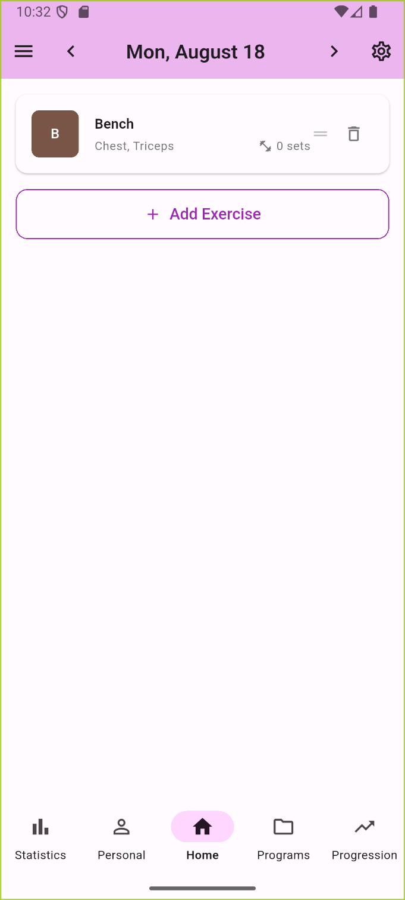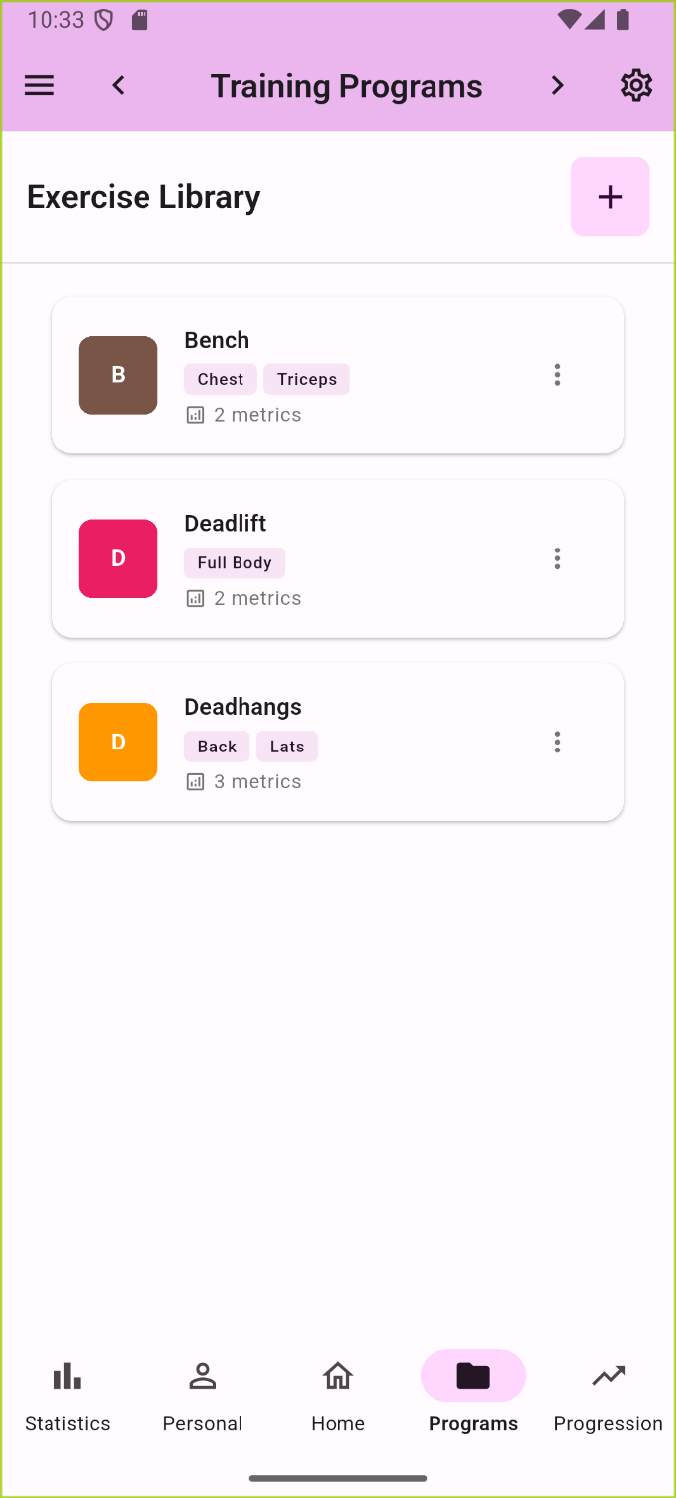

Reworked UI for the home and database to be more consistent with each other, although some more tweaking is still needed. This version also implements the proper theme system, which I finally figured out how to do properly after initially running into problems the first time around, which makes for much easier styling.

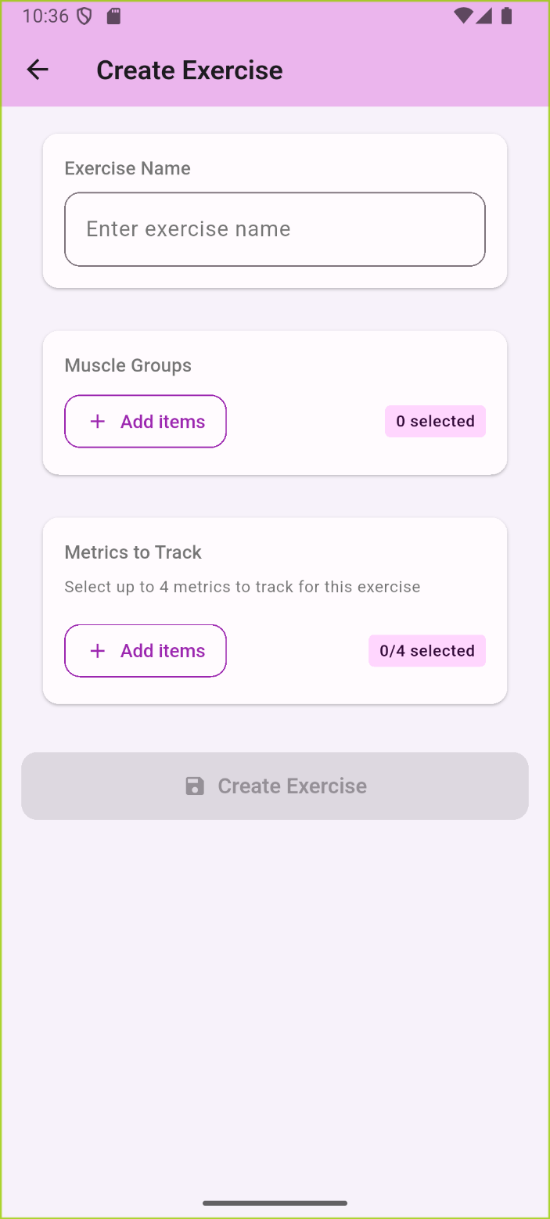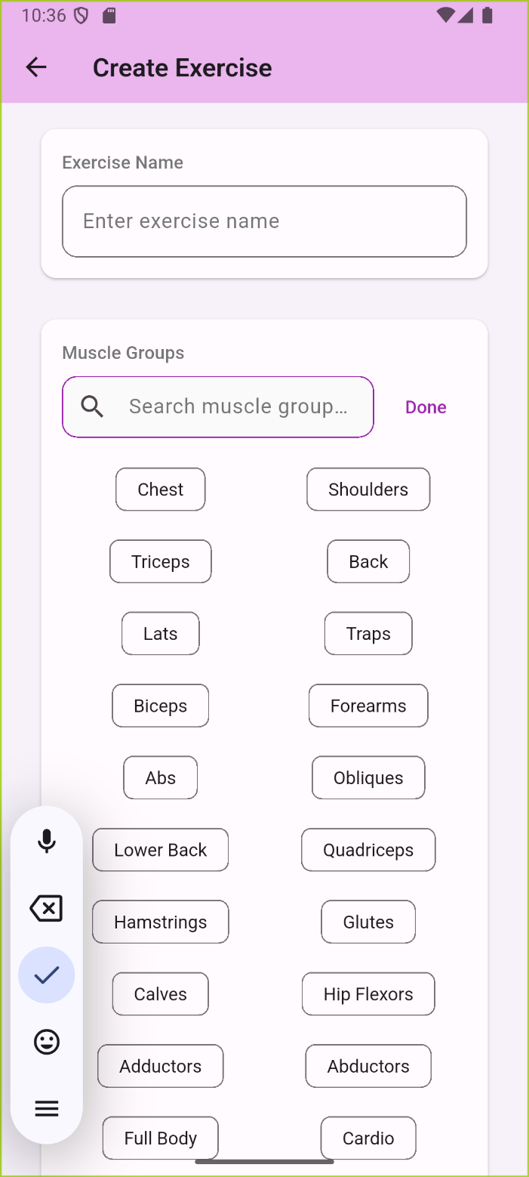

Further refinements to the exercise creation screen. I am still not very happy with it, because I can’t really figure out a way to do tags cleanly, but I have been experimenting with alignments to make it look a bit consistent, while also not making the screen very long in default state.

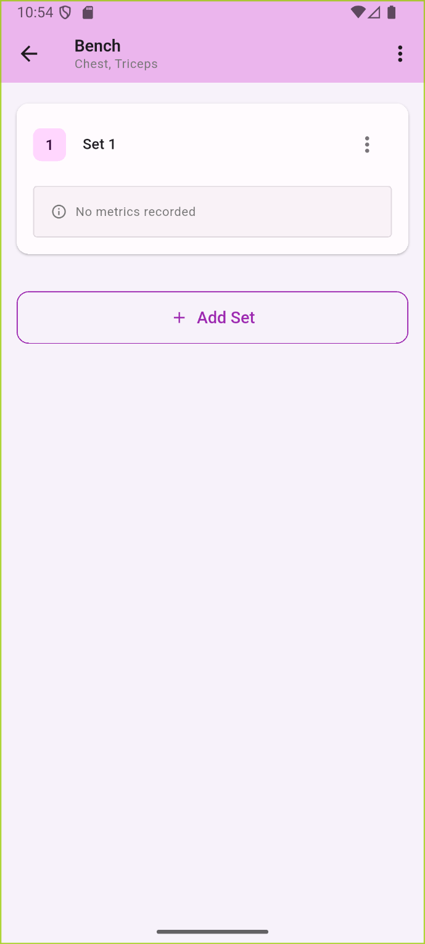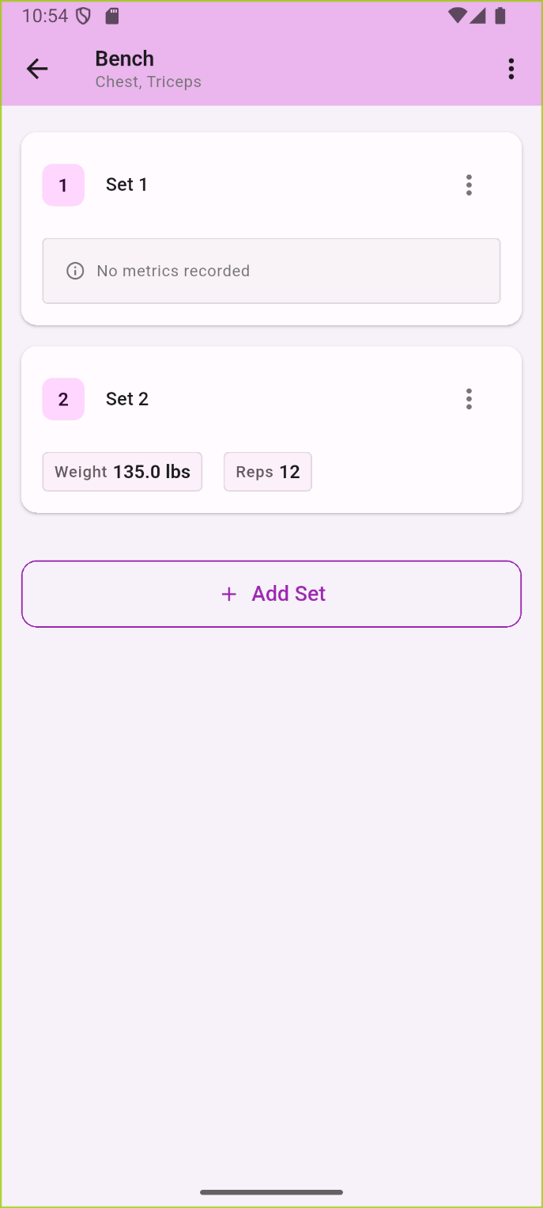

Finally, the screen for displaying an individual lift’s sets. It supports custom metrics, as well as the ability to avoid setting any metrics altogether if desired, one of the biggest gripes I personally have with many fitness apps. I tried to also keep consistent style here with the rest of the redesigned screens.

# Interaction Report

Interaction Type: Stakeholder

Interaction Date: 8/17/2025

Attendees: Fitness Enthusiast

## Summary of Interaction

Due to the fact that my initial pick for main stakeholder to interview was a bit underwhelming (I didn’t get much information, and they are iffy with using phones in general), I decided to meet with another person I had lined up, who is far more technologically proficient while still having extended fitness experience. Additionally, this offered an opportunity to show a much more functional version of my vision, which allowed for much higher quality feedback. The result is that I collected a lot of feedback on my overall design idea, implementation of metric system, as well as the usability of my app/UI. I have already started implementing some of changes, primary to the metric and muscle groups selection.

## Action Items

* The metric selection UI could be simplified and made to mimic the muscle group selection.
* The muscle group selection could be made into a cleaner version that doesn’t automatically display all muscle groups, while also having an extended mode which shows all options.
* The metric system is a good idea, and I can likely include some more metrics, particularly ones that include more imprecise data like overall feeling on exercise.
* Could introduce an archive system instead of pure deletion of exercises, to allow for keeping of past workout data, with option to purge items from archive if needed.
* Bigger buttons for main actions, as their phone is quite small, and they would likely struggle with some of the navigation options.
* Pre-filling sets, while automatically clearing the forms when focused.
* Exportation functionality for CSV or XML to use with Excel.

## Reflection on the Interaction

Overall, this has been far more productive than the interaction with my previous stakeholder that doesn’t use fitness apps. They provided much more direct feedback on the overall design, with much more actionable items. I have already started implemented some of the suggested changes, mainly in the exercise creation.

# Interaction Report

Interaction Type: Code review

Interaction Date: 8/16/2025

Attendees: UI/UX Engineer

## Summary of Interaction

The person I initially planned to do my code review with ended up unavailable unless I was willing to schedule it in literally the last days of the quarter, so I instead opted for my second option. While they have less overall experience from pure time perspective, almost all of their experience comes from working with UI systems, so I thought it was appropriate. In the end, I ended up getting very high quality feedback on both the coding practices and the design practices I was implementing. I got suggestions on how to tackle some of my main issues, such as some of the monolithic files that have been festering and where to invest into testing, considering I have limited time left. There were also a lot of smaller specific things, but these were the major topics.

## Action Items

* Biggest thing was in regards to commenting. Paired with some of the monolithic code files that I have, they suggested I invest into making really detailed comments for the presentation layer, especially if I am going to be pausing development. This is mostly because the presentation code tends to often become quite large due to the way widgets are styled, so it’s one part of code that particularly benefits from really detailed commenting.
* Also I need to really refactor some files. I have at least 4 different files – home_bloc, navigator_shell, and exercise_detail_screen that have become extremely large. This is mostly a result of me not being sure how to correctly manage BLoC state, which I am much better at now. But if I don’t do it soon, it will likely become a problem as I start working on more complex features.
* I could invest in some better debug logs in the use-cases.
* I need better edge case handling across the board, along with better failure state resolution.
* There are interdependencies in the presentation layer that we found, that really shouldn’t be there anymore. They are mostly a holdover from the very first UI version.
* They also suggested diagramming the actual architecture of the app, now that I have it, to make it easier to build on in the future. This came from the fact that I had a legacy workout system which I scrapped, but forgot to actually get rid of.
* For testing, I should create automated testing for the domain and data layer, while primarily focusing on user testing for the UI. They said that for this scale, there is not as much point in automated UI testing.
* Redesigning the theme system with extensions, something I didn’t even know about.
* Finally, I should probably do a feature freeze and focus on polish before I move forward, as the above issues with likely make produce a lot of issues if I start introducing whole new systems at this point.

## Reflection on the Interaction

Overall, this has been the most productive interaction in this entire quarter, which I guess makes sense considering that it is most directly interacting with the actual code. I hope to implement most of the feedback in the next week, although admittedly I might not have enough time.